July/August 2021 Volume 22 Issue 4

Group Publisher
Markus Egger

Associate Publisher
Rick Strahl

Editor-in-Chief
Rod Paddock

Managing Editor
Ellen Whitney

Content Editor
Melanie Spiller

Writers in This Issue
Bilal Haidar
Joydip Kanjilal
Julie Lerman
Sahil Malik
Rod Paddock
John V. Petersen
Paul D. Sheriff
Helen Wall
Shawn Wildermuth

Technical Reviewers
Markus Egger
Rod Paddock

Art & Layout
King Laurin GmbH
Friedl.raffeiner@tin.it

Production
Franz Wimmer
King Laurin GmbH
39057 St. Michael/ Eppan, Italy

Printing
Fry Communications, Inc.
800 West Church Rd.
Mechanicsburg, PA 17055

Advertising Sales
Tammy Ferguson
832-717-4445 ext. 26
tammy@code-magazine.com
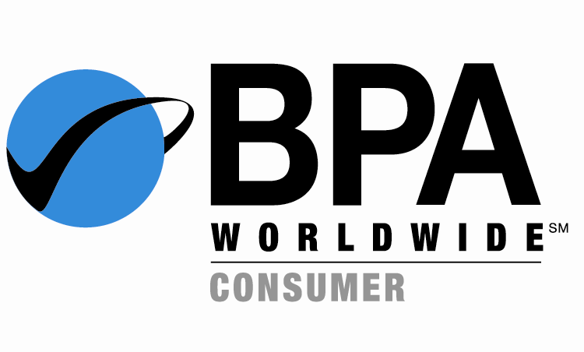

Circulation & Distribution
General Circulation: EPS Software Corp.
Newsstand: Ingram Periodicals, Inc.
International Bonded Couriers (IBC)
Media Solutions
Source Interlink International

Subscriptions

Circulation Manager
Colleen Cade
832-717-4445 ext. 9
ccade@codemag.com

US subscriptions are $29.99 USD for one year.
Subscriptions outside the US are $49.99 USD.
Payments should be made in US dollars drawn
on a US bank. American Express, MasterCard,
Visa and Discover credit cards accepted.
Back issues are available. For subscription
information, email subscriptions@code-magazine.com
or contact customer service at 832-717-4445 ext. 9.

Subscribe online at
www.code-magazine.com

CODE Developer Magazine
EPS Software Corporation / Publishing Division
6605 Cypresswood Drive, Ste 425, Spring, Texas 77379 USA
Phone: 832-717-4445

